**How to run the Junit Tests:**

Open the project folder using Eclipse IDE.

1. The folder src contains the Plannner package which has the program class files classes files

2. The folder test contains the unitTests package which contains the JUnit 5 test files. Class Tests contain this import line. import org.junit.jupiter.api.Test;

3. If any error occurs make sure that JUnit 5 and JUnit 4 are added to the project build path

**Testing the classes**

Naming convention: Tests are named by Class Name followed by the test type.

We have the following test classes file names.

|  |  |  |  |
| --- | --- | --- | --- |
| Number | Class | Test File | |
| 1 | Calendar | CalendarEncapsulationTest.java | |
|  |  | CalendarExceptionTest.java | |
| 2 | Meeting | MeetingEncapsulationTest.java | |
| 3 | Organization | OrganizationEncapsulationTest.java | |
|  |  | OrganizationExceptionTest.java | |
| 4 | Person | PersonEncapsulationTest.java | |
|  |  | PersonExceptionTest.java | |
| 5 | Planner | PlannerEncapsulationTest.java | |
| 6 | Room | RoomEncapsulationTest.java | |
|  |  | RoomExceptionTest.java | |
| 7 | Automated boundary value and equivalence partitioning | | BlackBoxTest.java |
| 8 | Automated schedule meeting | | ScheduleMeetingTest.java |
| 9 | Encapsulation Test Suite | | EncapsulationTestSuite.java |
| 10 | Exception Test Suite | | ExceptionTestSuite.java |

**Running the Unit Tests**

1. Right click on test File

2. Click Run As

3. JUnit

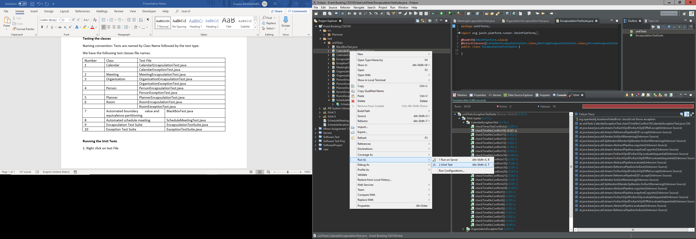

Failures from the results can be recreated by running the program as a console app and entering the same values as on the unit test method arguments.

If the tests are not running as intended.

Right click test file -🡪 Run As 🡪 Run Configurations 🡪 Run a single test - Set Test runner to JUnit 5 🡪 Apply 🡪 Run